**Webportal Code Guide**

|  |  |  |  |
| --- | --- | --- | --- |
| **Revision** | **Date** | **Author** | **Comment** |
| 1.0 | 06/26/2019 | Lavi | Initial version |
|  |  |  |  |

### Features are grouped by device type:

### 

“Features” here refer to “Functionality” in Switch automation framework. Each feature will have sub-features. For all different features like vlan, lag, radius under Switch feature. Normally we have AP, Orbit, Switch three main top features.

Webelements and weboperation are not features. They are same as “DESC” in switch framework. First package contains all of HTML element like button, text field, listbox. Later on contains all of function to wrap/handle these elements for test script.

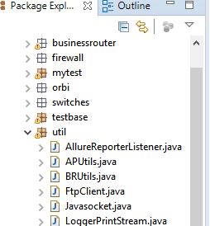

“Util” package like “GUI_LIB/support” in switch framework, it handles other functional method to device or webportal framework.

### Explanation for Testcase.java

**public** **class** Testcase **extends** TestCaseBase {

@Feature("BR.BRIPSecVpn")

// BR means it’s belong to BR feature (see device type above)

// BRIPSecVPN is feature name, refer to chart below:

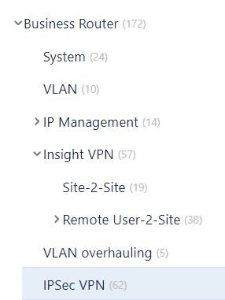

@Story("PRJCBUGEN_T13651")

@Description("035-Edit VPN Policy,change pre-shared key") // 对应用例名字

// Story is test case id from Jira, use _ instead of – please.

// Description is test name. 2 fields are from below PRJCBUGEN_T13648,



@TmsLink("PRJCBUGEN-T13651")

// TmsLink use test case id please from chart above

@Issue("PRJCBUGEN-13519") // It’s bug id from Jira as well

@Test(alwaysRun = **true**, groups = "p2") // p2 is priority from Jira(p1 – high, p2 – normal, p3 – low)

**public** **void** test() **throws** Exception {

runTest(**this**);

}

@AfterMethod(alwaysRun = **true**)

**public** **void** tearDown() {

// put your step once all test steps were done

}

@Step("Test Step 1: Login web portal success") // This is step description from Jira test case

**public** **void** step1() {

// API runTest will call steps from 1 from n like 99 for you.

### STS setup

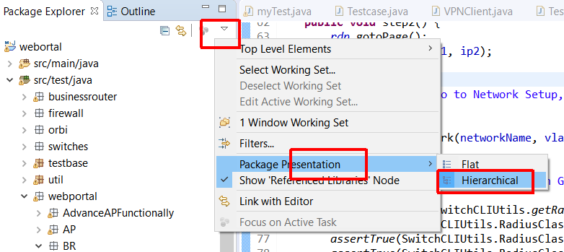

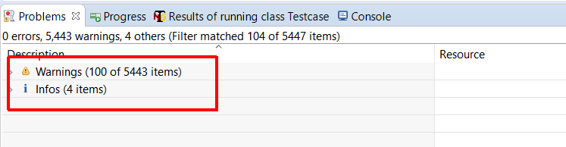

### Chrome to locate element

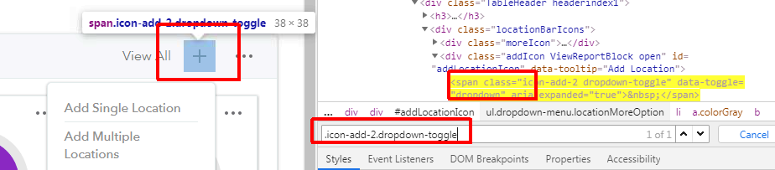

### How to mark test case in Jira before starting work

